RIVIERA CLUB ON THE GULF
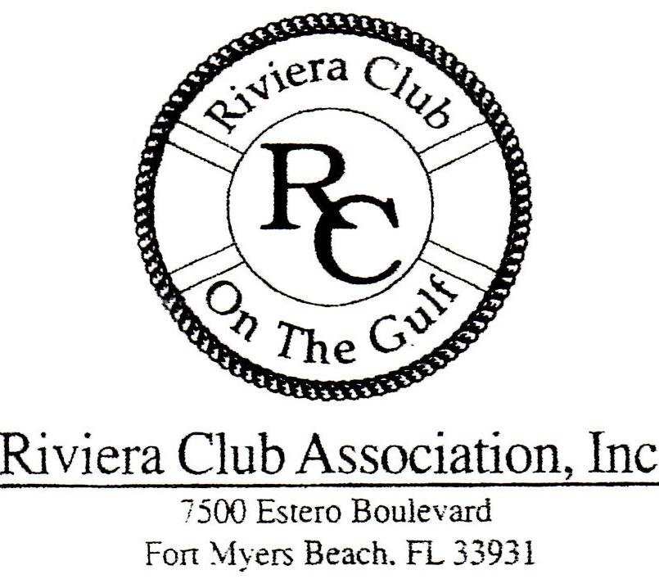
On Line Registration Instructions

- All Owners and Renters Required To Register
- All Fields of the Registration Form Need To Be Completed
- Renters Without Vehicles enter NA In Vehicle Information Fields
- Complete The On Line Registration Form
- Hit Submit Button. Form Goes To Registration Office
- Registration Form Received On Site RIV7500@gmail.com
- Renters Pick Up Parking Pass at Lobby Desk
- Owners Receive Permanent White/Blue Parking Pass 
- Renters Place White/Yellow Parking Permit on Mirror
- Parking Pass Generated at Riv7500@gmail.com
- No Parking Passes Issued Without Completed Registration
- Completion Of This Form Certifies All Information Is Accurate

Note: Minimum Two Week Rentals Per HOA.

Questions? Go to Riv7500@gmail.com

